ETHlogo

**Lecture with Computer Exercises:**

**Modelling and Simulating Social Systems with MATLAB**

Project Report

|  |
| --- |
| Smart Microgrid with Electric Vehicles |

Xingliang Fang

Seoho Jung

Huiting Zhang

Zürich

11 December 2015

**Agreement for free-download**

We hereby agree to make our source code of this project freely available for download from the web pages of the SOMS chair. Furthermore, we assure that all source code is written by ourselves and is not violating any copyright restrictions.

Zürich, 11 December 2015

Xingliang Fang

Seoho Jung

Huiting Zhang



Smart Microgrid with Electric Vehicles

**Table of Contents**

|  |  |  |
| --- | --- | --- |
| **1**  **2**  **3**  **4**  **5**  **6**  **7**  **8**  **9**  **10** | **Abstract**  **Individual Contributions**  **Introduction and Motivations**  3.1 Background  3.2 Objectives  **Description of the Model**  4.1 EV Agent Model  4.2 Alternative Charging Plans  4.3 EPOS  **Implementation**  5.1 Overview  5.2 Driving Profile Generation with NHTS Travel Data  5.3 State of Charge (SOC)  5.4 Power Consumption  5.5 EPOS  **Results and Discussion**  6.1 Preliminary Experiment  6.2 Effect of Charging Plans on Robustness  6.3 Effect of Number of Flexible EVs on Robustness  6.4 Effect of Number of Flexible EVs on Robustness  **Summary and Outlook**  **Acknowledgements**  **References**  **Appendix** | 5  6  7  9  14  24  31  33  34  35 |

**1 Abstract**

As the number of electrical vehicles (EVs) is expected to keep increasing, simultaneous charging of EVs will have considerable effects on the load of power grids in the near future, posing new challenges but also providing opportunities for planning smart microgrids. We construct a model for smart microgrid of EVs, in which the EV agent assigns charging plans to EVs based on collected information about power consumption needs. Based on real driving database, original and alternative charging plans of EVs are simulated in MATLAB, and the robustness or the total cost of microgrid is optimized. From the experimental result, the increase of the number of EVs accepting alternative plans can significantly increase the robustness of grid and lower the total energy cost, making the smart microgrid a promising solution to be deployed in the future.

**2 Individual Contributions**

Throughout our project, all three members were active and contributed equally in the progress. The coding and simulation on MATLAB were conducted as a teamwork of all three. More specifically, Xingliang was responsible for collecting and editing the original data, Huiting contributed more on analyzing the results, and Seoho made more effort on writing the report.

**3 Introduction and Motivations**

**3.1 Background**

In an electrical grid system, power generation and consumption should be balanced at all times because an imbalance between them may lead to problems such as voltage fluctuation and power outage. Therefore, a grid system has been designed to have generation capacity greater than the maximum peak demand, which occurs no more than a few times a year.[1] The costs of meeting the peak demand have been significant as generators, transmission lines, circuit breakers, and transformers have been largely underutilized during off-peak hours.[2] The daily peak demand usually occurs around 5:30 PM, due to office use, domestic demand, and, in certain seasons, the fall of darkness.[3]

Our study first started with a conjecture that, along with the already existing factors mentioned above, simultaneous charging of electric vehicles (EVs) during evening hours would further raise the daily peak load. Although EVs only comprise a small portion of the automotive market at the moment, the sales of EVs have surpassed a million since their mass market began only five years ago.[4] Thus, we supposed that, in near future, our grid system will have to either increase its generation capacity or efficiently alleviate the peak demand in order to supply enough power required to charge hundreds of thousands of EVs every day. The first option seems less ideal because it will lead to even more severe underutilization of facilities. The second option—alleviating the peak demand—secures higher grid robustness, the ability of a network to withstand an unexpected event without degradation in performance.[5] In a grid system that supports electric vehicles, a lower peak load induced by EVs directly leads to greater capacity to serve other unexpected demands. Efficient demand management can be achieved in a few different ways.

A smart microgrid, a modern and localized network, has been considered one possible solution because of its active decentralized management of demand. Unlike a traditional, centralized grid (macrogrid), a microgrid actively responds to locally collected demand information. Therefore, in this study, we have modeled a smart microgrid with EVs, which collects local power consumption information and determines when each of its member EVs should be charged.

**3.1 Objectives**

This study uses a mathematical model and simulation to analyze a smart microgrid with EVs. Our study addresses the following questions:

* How does the total power consumption of a smart microgrid change throughout a day? When does the peak demand occur?
* How and how much can this peak demand be alleviated?
* How and how much does the microgrid save total cost?
* How does the microgrid find its optimal solutions for grid robustness and cost reduction?

**4 Description of the Model**

**4.1 EV Agent Model**

Our study adopts EV agent model that was introduced by *López et al.* in 2011.[6] EV agent is a conceptual demand management agent; in our model, it is responsible for finding optimal charging solutions based on collected information about participating EVs. Figure 1 schematically illustrates the communication between EV agent and EVs. When an EV arrives home, instead of charging immediately, it sends information about its current state of charge(SOC) and next scheduled departure time. The EV agent processes such information from all participating EVs and sends back to each vehicle a charging plan, which contains information about when and how the vehicle should charge.

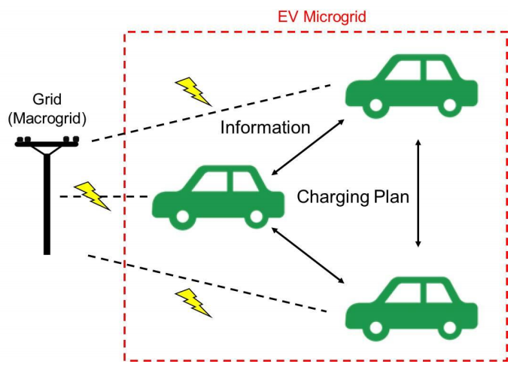

Figure 1: Schematic diagram of EV agent model

Our model is based on a number of simplifying assumptions:

* All vehicles are the same model and thus have the same technical specifications—for example, battery capacity, fuel economy, and plug-in charging rate. In our study, all vehicles are assumed to be Tesla Model S (2015 85D Option).
* Vehicles only charge at home. Although some vehicles use charging stations in reality, the majority of EVs still charge at home, making this assumption a reasonable abstraction. This assumption leads to the next assumption.
* EVs whose traveling distance between their departure from home and return exceeds the driving range of Tesla Model S (approximately 250 miles) are excluded from our analysis because excessively long journeys lead to a negative SOC value.
* Since our simulation runs for a day, vehicles that do not return home on the same day are also excluded from our analysis.
* All vehicles charge with a 240V charging cable. (Charging rate: approximately 9.6 KW)[7]
* If not given an alternative plan, all vehicles start charging upon their arrival at home.
* Driving profiles are generated based on travel data in Texas.
* Electricity pricing follows the actual residential electricity prices in El Paso, Texas. The peak hour price, which occurs from 12:00 to 20:00 daily, is 0.15831 USD/KWh; the off-peak price is 0.06743 USD/KWh.[8]

In order to understand the influence of EV charging on grid robustness, we should first find EVs’ total power consumption from the grid over time. Total power consumption is the sum of individual power consumption. A charging EV—SOC of which is increasing—draws 9.6 KW of power from the grid. Therefore, individual power consumption at time *t* can be defined by a simple piecewise function:

$$\left(individual power consumption\right)=\left\{\begin{aligned}9.6 KW (charging) \\ 0 (not charging)\end{aligned}\right.$$

And total power consumption at *t* is defined as follows:

$$\left(total power consumption\right)= \sum{\left(indiviual power consumption\right)}$$

$$=9.6 KW × (number of charging vehicles)$$

Next, to examine how much cost can be saved by our microgrid, daily total cost should also be calculated.

$$\left(daily individual cost\right)=9.6 KW × \left(peak charging hours\right) × \left(peak price\right)$$

$$+ 9.6 KW × \left(off-peak charging hours\right) × \left(off-peak price\right)$$

$$\left(daily total cost\right)= \sum{(daily individual cost)}$$

**4.2 Alternative Charging Plans**

When an EV is parked at home, it informs the EV agent how much time it needs to be fully charged and when its next departure is. EV agent makes one of the two following decisions:

1. (time until next departure) – 60 minutes $≤$ (time required for charging)

: charges the EV immediately (original charging plan)

1. (time until next departure) – 60 minutes $>$ (time required for charging)

: sends back an alternative charging plan

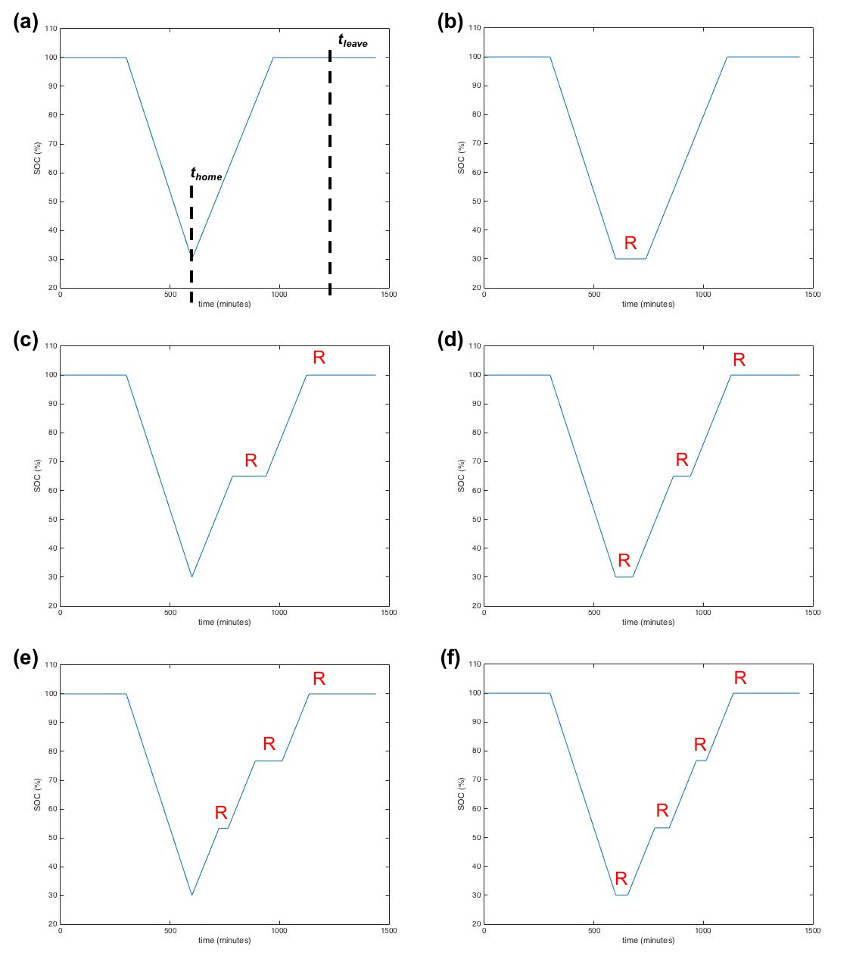 Figure 2: SOC curves with different charging plans

(a) original charging plan, (b)-(f) alternative charging plans 1 through 5

Alternative plans are designed to alleviate peak load by shifting some EVs’ power consumption or dividing charging into two or three steps. Before and after each charging step, there are pauses of random lengths (marked with “R” in Figure 2), which play a key role in randomly shifting charging steps.

Figure 2 shows the daily SOC curves with an original charging plan and five alternative charging plans. Here, a very simple SOC curve is presented as an example. This sample vehicle is used and thus discharges from 5:00 to 10:00; it starts charging at 10:00 (*thome*); it needs approximately 6 hours to be fully charged and its next scheduled departure is at 20:00 (*tleave*), it fulfils the condition to receive an alternative plan. The curves in Figure 2(b) through 2(f) show that SOC between *thome* and *tleave* changes differently as different alternative charging plans are applied. Table 1 characterizes all charging plans. In Alternative Plans 2 and 4, the first charging step starts immediately; however, the second and third steps are placed randomly.

|  |  |  |  |
| --- | --- | --- | --- |
|  | Start | Number of Steps | Figure |
| Original Plan | Immediate | 1 | 2(a) |
| Alternative Plan 1 | Random | 1 | 2(b) |
| Alternative Plan 2 | Immediate | 2 | 2(c) |
| Alternative Plan 3 | Random | 2 | 2(d) |
| Alternative Plan 4 | Immediate | 3 | 2(e) |
| Alternative Plan 5 | Random | 3 | 2(f) |

Table 1: Charging plans

**4.3 EPOS**

EPOS, namely Energy Plan Overlay Self-stabilization system, is a decentralized agent-based optimization engine to coordinate participants’ energy plans with respect to a certain energy utilization objective.[10] In our microgrid model, EPOS serves as the global optimization mechanism of EV agent. In EPOS, each agent is defined as a software program, which can automatically control the activities of a group of energy exchange devices, and alter its energy utilization based on the communication with other agents. The main mechanism and structure of EPOS are as follows:[11]

1. Organize agent connection based on tree topology

EPOS builds up the agent-network in a tree topology. It automatically assigns each agent to a certain level, at which several agents belong to an upper parent. In contrast to the conventional centralized optimization, EPOS does optimization in a decentralized bottom-up approach. In other words, each parent can locally generate an optimal plan with its children and send its local aggregate plan to the upper level, till the global optimization is complete.

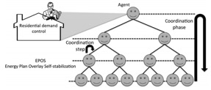

Figure 3: Tree topology used in EPOS

1. Optimize based on exploited alternative plans

EPOS assumes that every individual software agent can exploit various energy utilization plans for a certain time period (e.g. power consumption profile for the next 24 hours). Each agent owns at least one plan and EPOS can only do the optimization by selecting available plans. As each household can define the plan-generating strategy of its agent, the preference of each household can be fully respected and guaranteed.

1. Optimize global energy utilization based on local selections

EPOS requires an objective function that defines the common goal of global energy utilization, such as the robustness and cost of a grid. Based on already-made local selections and the objective function, it accomplished desired optimization.

And based on its mechanism, EPOS possesses the following advantages:

1. Compatibility with power or Internet infrastructures

Compared to a centralized structure, the tree topology of EPOS is much more similar to the structure of Internet or grids in reality. Therefore, because of this structure, it is feasible to transform this visual engine into a real-life application in the future.

1. Quickness in large-scale optimization

Because the optimization workload can be distributed and localized in a smaller scale, EPOS can obtain a much faster optimization speed compare to a centralized engine. It is a very crucial aspect of performance considering the future size of a EV microgrid, which may include thousands of households.

1. Privacy with distributed communication and decision making

As every parent can only “see” the plans of its closest children, the details of lower-level decision process are naturally hidden. Therefore, the data privacy of individual plans can be guaranteed by this restricted data accessibility.

Section 5.5 describes how EPOS functionalizes in our workflow.

**5 Implementation**

**5.1 Overview**

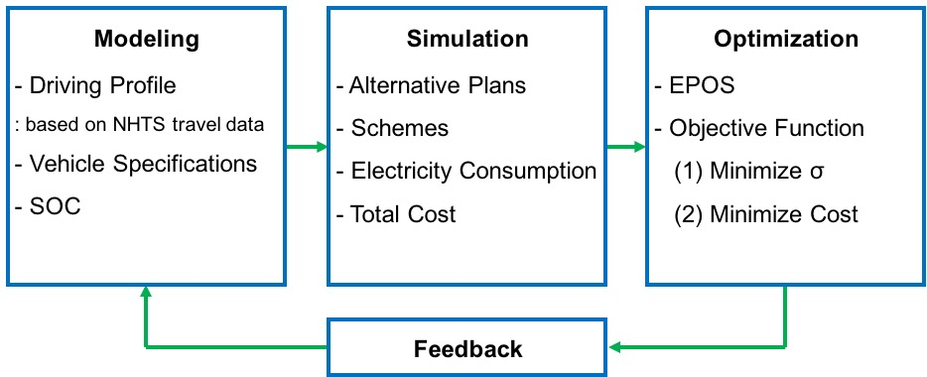

Figure 4: Flow diagram of our implementation

Figure 4 illustrates how our project is implemented. First, we find input data that construct the building blocks of our model; these include driving profiles, vehicle technical specifications, and original SOC vectors.

A driving profile of a vehicle should include information about the location and speed of the vehicle at each minute because it indicates when a certain vehicle is available for charging and how its SOC changes over time. In order to maximize the feasibility of our study in real life, we generated realistic driving profiles from actual travel data of vehicles.

As described earlier, we assume that all vehicles in our EV microgrid are Tesla Model S. Thus, all vehicles have the technical specifications same as those of Model S. These data determine how fast a vehicle is discharged when it travels a certain distance and how long it takes to fully charge a vehicle.

With driving profiles and vehicle specifications, we generate the SOC vectors of all vehicles when they are not given any alternative charging plans. Each element in this 1 $×$ 1440 vector indicates a vehicle’s SOC level at every minute.

The simulation stage finds modified SOC vectors of vehicles that are given alternative charging plans, as exemplified in Figure 2. And we the total electricity consumption and cost by using the relations introduced in Section 4.1.

With the simulation results, EPOS determines which charging plan should be assigned to which vehicle. Its result varies as a different objective function is applied. In our experiments, our objective is either (1) maximizing grid robustness (minimizing standard deviation of power consumption), or (2) minimizing total cost.

**5.2 Driving Profile Generation with NHTS Travel Data**

The charging behaviors of batteries in electric vehicles depend on the driving profiles of these EVs, because the driving profiles determine how much the vehicles are discharged and when the batteries are available to be charged. In our study, a set of driving profiles is constructed using data from the 2009 National Household Travel Survey (NHTS).[12] A driving profile for one vehicle consists of two vectors, each vector indicating traveling speed and location throughout at each minute, which are derived by using two functions, *FUNC_speed.m* and *FUNC_location.m,* respectively.

**5.2.1 Extracting Data from NHTS Database**

The NHTS is conducted by the Federal Highway Administration of United States by interviewing persons in 70,000 households in US about their traveling behaviors during certain days. The results are organized into four different data files, among which the day trip file containing “data about each trip the person made on the household’s randomly assigned travel day” is applicable for our research.[13] We select 6 variables that are applicable for our research from more than one hundred in the NHTS’ day trip file. The names and the explanations as well as the meanings of the values of the variables are listed in Table 2.[14]

|  |  |  |
| --- | --- | --- |
| Name | Explanation | Values ranges and their meanings |
| HOUSEID | HH eight-digit ID number |  |
| PERSONID | Person ID number |  |
| ENDTIME | Trip END time in military | 0000-2359, corresponding to time in a day 00:00-23:59 |
| TRVL_MIN | Trip time - minutes | 0-1230 |
| WHYTO | Travel day purpose of trip | 1. Home   10-14 Work related  20-24 School related  30- Medical/dental services  40-43 Shopping related  50-55 Social related  60-65 Family related  other: other reasons |
| TRPMILES | Calculated Trip distance converted into miles | 0-9000 |

Table 2. Variables selected in the datasets

Considering the physical scale of a realistic microgrid, only households in Texas are used in our analysis. The data are selected and imported into MATLAB by using the command lines in *gen_Matlab_data.m*.

**5.2.2 Generating Speed Profiles of EVs**

The speed profile of an EV gives information about the speed of the given EV at each time point in the day. This information is necessary when we attempt to obtain the discharging rate of the batteries. To derive these speed profiles, we construct the *FUNC_speed.m* function. The unit of time is 1 minute, as in all of the other functions. We firstly generate a subtable containing 'ENDTIME', 'TRVL_MIN' and 'TRPMILES' of trips conducted by the first person in the given HOUSEID.

% Select the row for a given houseid

% Only select the first member of the household whose PERSONID == 1

rows = table.HOUSEID==oused & table.PERSONID==1;

subtable= table(rows, {‘ENDTIME’, ‘TRVL_MIN’, ‘TRPMILES’});

Figure 5: Implementation to make a subtable with households’ first individuals

Only one person is taken into consideration because, in case two or more household members move in one vehicle, multiple journeys are recorded in NHTS dataset although they may be actually one trip from the vehicle’s perspective. Each row of the subtable represents a single trip. We define the speed during the travel period as constant and thus it can be calculated as:

$$(speed)=\frac{(travel distance)}{(travel time)}$$

The travel distance and time are directly obtained from variable ‘TRPMILES’ and 'TRVL_MIN', while the starting point, ‘ENDTIME’ – ‘TRVL_MIN’, and the end point, ‘ENDTIME’, define a travel period. It is noticeable that 'ENDTIME'-'TRVL_MIN' as starting point might go zero or negative sometimes, which means the trip started before midnight. In these cases, we just define start point to be 1 as our time scope is only one day from 1 to 1440 minutes. These implementations are realized as in Figure 6.

for i=1:height(subtable)

t_start=subtable.ENDTIME(i)- subtable.TRVL_MIN(i);

if t_start<1

t_start=1;

end

t_range= t_start:(subtable.ENDTIME(i) - 1);

speed(t_range)= subtable.TRPMILES(i)/subtable.TRVL_MIN(i);

end

Figure 6: Implementation to set up starting and end points of a journey

The final output of this function is a one-dimension vector where each element is the speed value at each minute in the day.

**5.2.3 Generating Location Profile of EVs**

The location profile of a EV shows where the EV is during a day. Three values are to be assigned at each time point, which are respectively representing: ‘1’ as “at home”, ‘-1’ as “on road”, ‘0’as “at other places”. These definitions later determine the state of charging of the batteries, *i.e.,* batteries are available to be charged at home (represented as ‘1’), and are discharged on road (represented as ‘-1’), while they would not be charged nor discharged at other places (represented as ‘0’). The *‘FUNC_location.m’* function is constructed to get the location profiles.

Similar to the process of speed function, we create a subtable containing 'ENDTIME', 'TRVL_MIN', 'TRPMILES' and a new variable ‘WHYTO’ of trips of the given person.

%Selcet data for the given houseid

%only select the first person, which means PERSONID=1

rows = table.HOUSEID==houseid & table.PERSONID==1;

subtable= table(rows, {'ENDTIME','AWAYHOME', 'TRVL_MIN', 'WHYTO' });

Figure 7: Implementation to generate a subtable for location profiles

For each trip, we first determine the length of the trip. We define the location value during these period is ‘-1’ as explained previously. Since we have the information of ‘WHYTO’, we know the location of the vehicle after this trip. Therefore, from the next minute after the starting point to the last minute before the next trip (or the last minute of the day), we can assign value to the location according to the value of ‘WHYTO’, which is achieved as following:

period= subtable.ENDTIME(i)- subtable.TRVL_MIN(i): subtable.ENDTIME(i)-1;

for t=period(period>0)

location(t)=-1;

end

% consider the cases when the vehicle is not moving

% change the location

t=t+1;

if t<1

t=t+1;

end

while (speed(t)==0) && (t<=(60*24-1))

if subtable.WHYTO(i)==1

location(t)=1;

else

location(t)=0;

end

t=t+1;

end

Figure 8: Implementation to determine location

To point out, such a method does not cope with the location before the first trip, so we initialize the location values as ‘1’, assuming every vehicle stays at home before any trips are conducted.

%Initialization

location=ones(1,60*24);

Figure 9: Implementation to set default location as home

The final output of this function is an one-dimension vector where each element is the location value at each minute (‘1’- “at home”, ‘-1’- “on road”, ‘0’- “at other places”) in the day.

**5.3 State of Charge (SOC)**

**5.3.1 State of Charge with Regular Charging Plan**

In order to find the total power consumption and electricity cost of the microgrid, we first find the SOCs of each vehicle for a day, from *t* = 0 to *t* = 1440 minutes. Figure 10 illustrates the steps to calculate SOCs with the NHTS travel data.

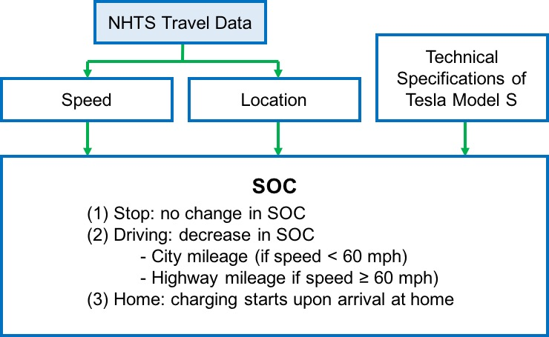

Figure 10: Calculation of SOC

With the speed and location profiles generated by the procedures described above, we referred to the technical specifications of Tesla Model S, in order to calculate the SOC at *t*. The values that were used in our simulation include *Battery Capacity* = 85 KWh, *Charging Rate* = 9.6 KW, *City Fuel Economy* = 3.00 mi/KWh, *Highway Fuel Economy* = 3.03 mi/KWh.[7]

*FUNC_SOC.m* finds the SOC curve of each vehicle. As described in Figure 10, if a vehicle stops at a location other than home, there is no change in SOC. If a vehicle is on the road, the discharging rate is determined by the speed of the vehicle. Battery charging starts as soon as a vehicle arrives at home—at time *t* when the car’s *location* value first changes to 1.

Figure 11 shows the SOC curve of a sample vehicle (HOUSEID = 32957150). The flat line segment marked in blue indicates that the vehicle is parked somewhere other than home during the time period. The upward curve, marked in red, represents the charging of the vehicle, which starts as soon as it comes back home.

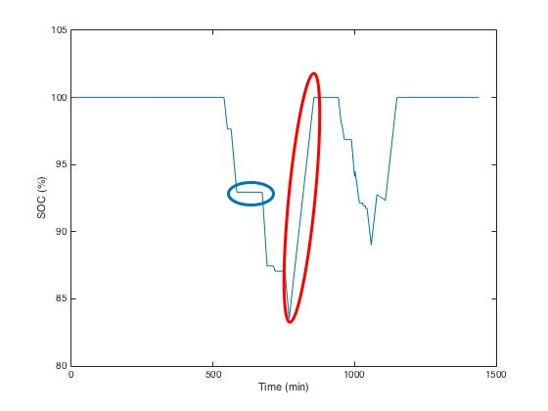

Figure 11: Sample SOC Curve

After SOCs of all vehicles are found, the vehicles whose SOC goes below 0 at any point in time are excluded from our analysis. Since our model does not consider the possibility of recharging electric vehicles at charging stations, the SOC vector of a vehicle that travels further than approximately 250 miles—the driving range of Tesla Model S—without coming home includes negative numbers. We convert the SOC vectors of such vehicles into NaN’s, as shown in Figure 12.

% Convert SOC vectors with negative elements into NaN’s

if any(SOC<0)

SOC=NaN;

end

Figure 12: Implementation to delete vehicles with negative SOC elements

**5.3.2 State of Charge with Alternative Charging Plans**

After each vehicle’s regular SOC vector is determined, we find the SOC vectors when alternative charging plans are applied. As illustrated in Figure 2, the most notable feature in the alternative plans is that there are pauses of random lengths before and after charging steps. For example, Figure 2(f) shows that there are 4 pauses in the Alternative Plan 5. Once the total amount of time available for pauses is determined, the length of each pause is determined relatively. The implementation code is available in Figure 13.

If an alternative charging plan is applied, a new 1×1440 SOC vector is generated as an output. In the new alternative SOC vector, the elements in the time interval between *thome* and *tleave* are replaced. If a vehicle leaves and comes home multiple times, there can be more than one time intervals in which the SOC values are replaced.

% pauseTotal is the sum of all pauses between charging steps [in minutes]

pauseTotal = t_leave - t_home - t_charge - 60;

% In this alternative plan, there will be four pauses

R = rand(1,4);

pause1 = round((R(1)/sum(R))*pauseTotal);

pause2 = round((R(2)/sum(R))*pauseTotal);

pause3 = round((R(3)/sum(R))*pauseTotal);

pause4 = round((R(4)/sum(R))*pauseTotal);

Figure 13: Implementation to randomly determine the lengths of pauses

**5.4 Power Consumption**

To analyze the effect of the EV microgrid on grid robustness, the total power consumption from the grid should be calculated. The calculation of total power consumption is done by EPOS, which requires individual power consumption vectors of all vehicles. Charging a Tesla Model S vehicle consumes 9.6 KW of power from the grid. With SOC vectors, the daily power consumption vector of each vehicle in the microgrid can be formulated by a simple code.

if SOC(t)-SOC(t-1)>0

electricity(t)=car.ChargeKW

end

Figure 14: Implementation to calculate power consumption at *t*

As seen here, if a vehicle’s SOC is increasing at a certain time, it must be charging and its power consumption rate at the given moment is 9.6 KW.

**5.5 EPOS**

In order to optimize global energy consumption by using EPOS engine, the conversion of the alternative plans into EPOS standard readable format becomes necessary.

As mentioned in the report above, the input data of each household should be several 1×1440 vectors, each vector representing the minute-wise power consumption with a different charging plan.

And also, EPOS can select plans based on the relative significance, which can be reflected by a weight scalar. Here, we set weight = 1.0 for every plan, assuming that every plan has the same likelihood of being selected. Therefore, the final input data (.plan file) should be formatted as:

Title: YYYY-MM-DD.plan (represents the date the file was created)

1.0: 0, 0, 0, 9.6, …… (weight=1.0, followed by 1440 numbers, separated by comma, in kW/h)

1.0: 0, 9.6, 9.6, 0, ……

Etc.

Figure 15: Sample .plan code

The detailed steps are as follows:

1. Construct EV pools and generate SOC profile

In order to better explain the effect of EV numbers and alternative plans patterns (schemes), other irrelevant variables, such as regions, day of travel, should be controlled.

In a single experiment, only households in the same state, such as Texas, are considered, based on the assumption that households in the same state are able to build up an EV microgrid and share the same electricity price. Further, being aware that households usually have different driving patterns between weekdays and weekends, we only use the driving profile collected on weekdays.

Therefore, the implementation should be:

load TexasTable % loading data of Texas from NHTS

load CarModel

row= (table.TRAVDAY<=5); % only consider weekdays

subtable=table(row,:);

HHpool = unique(subtable(:,{'HOUSEID'})); % construct household pools

Figure 16: Implementation to construct an EV pool

1. Detect and exclude invalid EVs

Some EVs may have NaN’s as their SOC file (because of the negative values in SOC vectors, see section 5.2). Also, some EVs, which have no interaction with the grid, have no change in SOC. These two kinds of EVs should both be excluded in our experiment.

count =1;

while count<=EV_number

SOCori=FUNC_SOC(subtable,HHpool.HOUSEID(i),model(car_index,:));

if isnan(SOCori(1,1))==0 && range(SOCori)~=0

………%(codes for generating .plan file)

count = count+1;

end

Figure 17: Implementation to exclude invalid EVs

1. Obtain alternative plans

if count<=plannedEV_number

altMatrix=FUN_SOCalter(SOCori,FUNC_location(table,HHpool.HOUSEID(i)),model(car_index,:),pattern);

else

altMatrix=SOCori;

end

Figure 18: Implementation to select an alternative plan

1. Generate EPOS readable “.plan” file

The .plans

for j=1:length(altMatrix(:,1))

fileID = fopen(filename,'a');

fprintf(fileID,'1.0:');

fclose(fileID);

dlmwrite(filename,FUNC_electricity(altMatrix(j,:),model(car_index,:)),'-append','delimiter',',')

end

Figure 19: Implementation to format a .plans file

1. Generate auxiliary file, such as price signal

The price signal is a text file with 1440 lines, one price scalar on each line. Here we use the electricity price of El Paso Electric Company in Texas.[8]

On-Peak: 0.15831 USD/kWh

Off-Peak: 0.06743 USD/kWh

The on-peak hours are defined as 12:00-20:00.

1. Run experiments on EPOS

The experiments are designed by controlling several parameters, which looks like the example below.

|  |  |  |  |  |  |  |  |
| --- | --- | --- | --- | --- | --- | --- | --- |
| Experiment Reference Name | # of Total EVs | # of flexible EVs | Scheme for Alternative plans | Car | State | Optimization Goal | |
| 151130_1k_1k_0135 | 1000 | 1000 | [0,1,3,5] | Tesla | Texas | Robustness | Cost |

Table 3: Sample EPOS experiment setup

Number of total EVs: the total number of EVs; reflects the scale of a certain EV neighborhood

Number of flexible EVs: the number of households willing to accept alternative charging plans; reflects the collaboration and flexibility of the EV neighborhood

Scheme for alternative plans: the combination of available alternative plans; for example, [0, 1, 3, 5] means each available household be assigned one of the 4 charging plans, one of which is the original (charging upon arrival) and the others of which are respectively alternative charging plans 1, 3 and 5

Car model: the car, technical specifications of which we use in the experiment

State: the location of households according to NHTS dataset

Optimization goal: the goal function; “Robustness” means to minimize the standard deviation; “Cost” means to minimize the total cost based on the on/off peak price signal.

**6 Results and Discussion**

**6.1 Preliminary Experiment**

A microgrid consisting of 500 households is virtually established in the preliminary experiment. Three schemes are constructed as shown in Table 4 and are simulated based on the virtual microgrid to evaluate their performances. It needs to be noted that the three alternative plan 1’s in Scheme 1 are all different; their charging steps start at different points. The purpose of the preliminary experiment is to validate the effectiveness of alternative plans and find out what can be further involved in our optimization. The the total power consumption curves with different schemes are illustrated inFigure 20.

|  |  |  |  |  |  |  |
| --- | --- | --- | --- | --- | --- | --- |
| Experiment Reference Name | # of Total EVs | # of Flexible EVs | Scheme for Alternative plans | Car | State | Optimization Goal |
| Original | 500 | 500 | [0] | Tesla | Texas | N/A |
| Scheme-1 | 500 | 500 | [0,1,1,1] | Tesla | Texas | Robustness |
| Scheme-2 | 500 | 500 | [0,2,2,2] | Tesla | Texas | Robustness |
| Scheme-3 | 500 | 500 | [0,4,4,4] | Tesla | Texas | Robustness |

Table 4: Preliminary experiment setup



Figure 20: Power consumption curves of the preliminary experiment

**Robustness of the grid**

As is shown in Figure 20, for the original power consumption where no alternative plans are included, there is a significant peak between *ca.* 16h00 to *ca.* 22h00 with a power load higher than 300KW and the top reaches 662KW while a valley where the power consumption is negligible occurs between *ca.* 1h00 to *ca.* 8h00. Such a drastic fluctuation has adverse effects on the robustness of the power grid. These trends confirm that our initial conjecture was reasonable and reinforce the necessity of an efficient demand response method.

Therefore, we evaluated the optimization of robustness using ‘MIN-DEVIATIONS’ as the selection function in this experiment. As the Figure 20 shows, schemes that provide the agents with alternative plans can significantly restrain the violent fluctuation of power load. Particularly with Scheme 1, the peak load during 16:00 to 22:00 is perfectly shaved and this part of power consumption is redistributed to fill the power valley during 1:00 to 8:00. Throughout the day, the power consumption with Scheme 1 fluctuates mildly within the range of 100KW to 300KW. With Schemes 2 and 3 respectively, there is still a peak starting around *ca.* 16:00, though the amplitude and duration have decreased. The cause of the peak can be explained as that EVs with alternative plans 2 and 4 will start charging the batteries to a certain amount of capacity immediately when they arrive home.

**Cost and diurnal driving**

When off-peak electricity pricing is applied, the power price during peak hours which is usually between 12h00 to 20h00 would be higher while it is showed in the simulation result that the peak of consuming electricity to charge EVs is exactly located in the peak price range. As a result, the cost for the customers would also increase, so minimizing the cost for the customers should also be included as another optimization goal in our further study.

Meanwhile, power consumption without any optimization is shown to be very stable during day time, implying that the optimization is only needed for the peak and valley hours. Moreover, the trips in day time are less predictable so people would prefer to charge as soon as they arrive at home. Therefore, we also expected that our alternative plans would not have much effect on the charging behavior in day time. This prediction was validated in this experiment, as all of the three schemes are shown to have very similar curves during day time.

As a tentative conclusion, we have verified in the preliminary experiment that our alternative plans are effective in redistributing the power consumption with little effect on people’s driving behavior during day time. But the alternative plans 2 and 4 should be modified to further shave the peak by introducing randomness to their first charging steps.

**6.2 Effect of Charging Plans on Robustness**

Based on the preliminary experiment, we have already observed the advantages of including randomness in the charging pattern. Therefore, we run three more experiments mainly based on the scheme where all charging steps of all alternative plans are positioned randomly, i.e. charging plans 1, 3 and 5. And the main purpose of these experiments is to look deeper into how the charging plans, flexibility of households, and optimization goal, affect the grid robustness and cost.

To compare the effectiveness of random charging plans 1, 3, and 5 on improving the grid robustness, we run the experiment in different schemes while keeping other variables unchanged, as shown in Table 5. The neighborhood is set to have the highest flexibility.

|  |  |  |  |  |  |  |
| --- | --- | --- | --- | --- | --- | --- |
| Experiment Reference Name | Number of Total EV | Number of EV with alternative plans | **Scheme for Alternative plans** | Car | State | Optimization goal |
| Benchmark | 1000 | 0 | [0] | Tesla | TEXAS | N/A |
| 151207_1k_1k_0111 | 1000 | 1000 | [0,1,1,1] | Tesla | TEXAS | robustness |
| 151207_1k_1k_0333 | 1000 | 1000 | [0,3,3,3] | Tesla | TEXAS | robustness |
| 151207_1k_1k_0555 | 1000 | 1000 | [0,5,5,5] | Tesla | TEXAS | robustness |
| 151207_1k_1k_0135 | 1000 | 1000 | [0,1,3,5] | Tesla | TEXAS | robustness |

Table 5: Second experiment setup (grid robustness)

As the robustness is defined as the total electricity consumption. Therefore, the lower the volatility of the curve, the higher the robustness. *All four schemes with alternative plans can significantly reach a more stable electricity consumption along the whole day.*And the best scheme ([0,1,1,1]) with standard deviation 160.95 can improve the benchmark situation 450.02 by 64.2%. It can be inferred that, by adopting random charging plans (plan 1, 3 or 5), the households can flexibly coordinate with other candidate by shifting individual load demand to non-busy hours, which contributes to the robustness of the grid.

*The charging steps in random charging plans do not make significance differences on the robustness of the grid.* The standard deviation of schemes with alternative plans are in the range of 160 to 188, where scheme [0,1,1,1] has the best performance. Because [0,1,1,1] uses alternative plans with 1 step charging, it will be easier to locally optimized by separating the initial starting points.



Figure 21: Power consumption curves of the second experiment

**6.3** **Effect of Number of Flexible EVs on Robustness**

|  |  |  |  |  |  |  |
| --- | --- | --- | --- | --- | --- | --- |
| Experiment Reference Name | Number of Total EV | **Number of EV with alternative plans** | Scheme for Alternative plans | Car | State | Optimization goal |
| Benchmark | 1000 | 0 | [0] | Tesla | TEXAS | N/A |
| 151207_1k_200_0135 | 1000 | 200 | [0,1,3,5] | Tesla | TEXAS | robustness |
| 151207_1k_400_0135 | 1000 | 400 | [0,1,3,5] | Tesla | TEXAS | robustness |
| 151207_1k_600_0135 | 1000 | 600 | [0,1,3,5] | Tesla | TEXAS | robustness |
| 151207_1k_800_0135 | 1000 | 800 | [0,1,3,5] | Tesla | TEXAS | robustness |
| 151207_1k_1k_0135 | 1000 | 1000 | [0,1,3,5] | Tesla | TEXAS | robustness |

Table 6: Third experiment setup (number of flexible EVs on robustness)

By changing the flexible household percentage, i.e. number of EV’s with alternative plans in a fixed community, we try to discover how and how much the number of flexible households can improve the robustness of the grid. By using the same household data as in the second experiment, with fixed alternative plan scheme [0,1,3,5], we linearly increase the number of flexible household to investigate the improvement of robustness (standard deviation).

*Increase of the flexible household percentage can improve the robustness of grid.*As percentage of flexible households increase from 0% (benchmark) to 100% (full collaboration), the positive effect on load shifting are always observed. Especially, it is obvious in the graph that the peak load value around 18:00 decreases, and the average midnight consumption increases, when increasing the flexible household percentage.

*The grid robustness, measure in standard deviation, has negative near-linear relationship with the percentage of flexible households.*The Figure 23, shows good linearity between these two variables. It can be inferred that, people can have a linear expectation of grid robustness improvement when increase the cooperation level of microgrid. Every marginal individual who joins the microgrid, can have a similar contribution to the robustness.

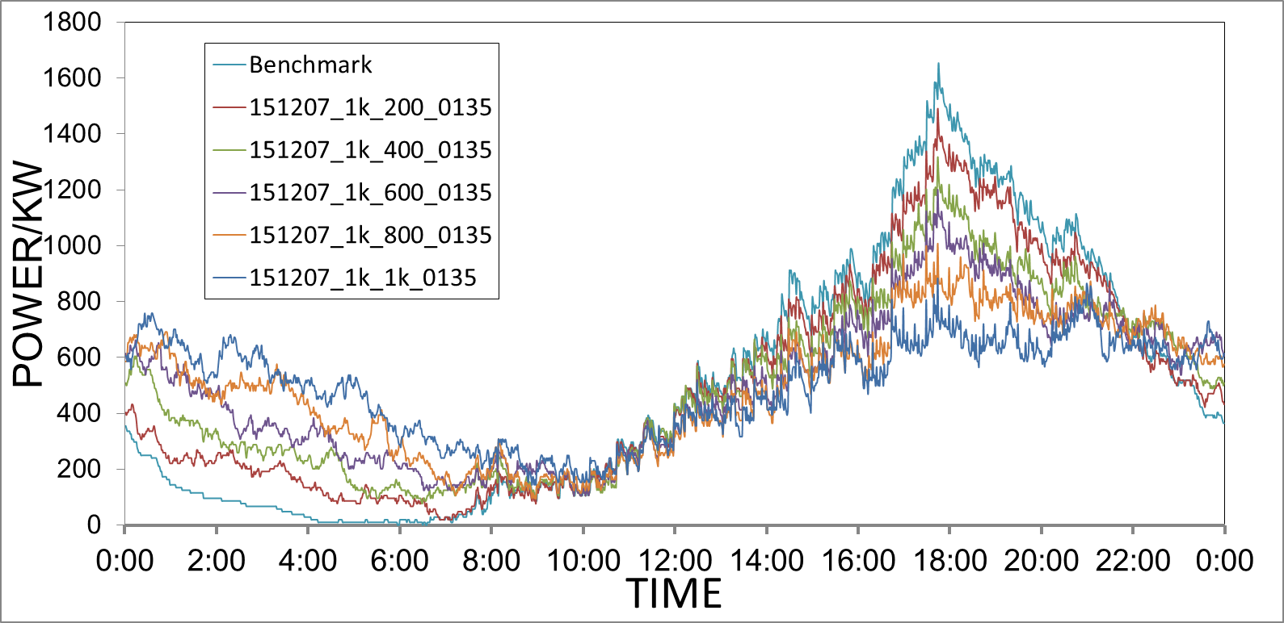

Figure 22: Power consumption with variable numbers of flexible households

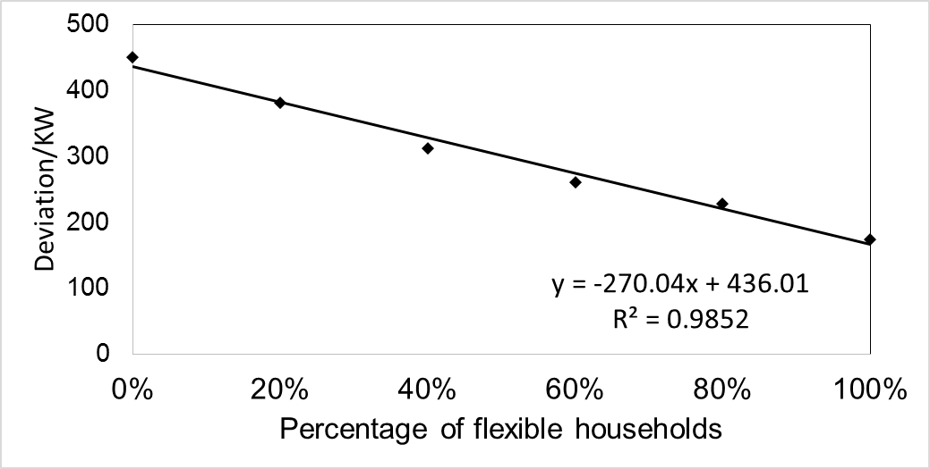

Figure 23: The relation between deviation and percentage of flexible households

**6.4 Effect of Number of Flexibility EVs on Cost**

|  |  |  |  |  |  |  |
| --- | --- | --- | --- | --- | --- | --- |
| Experiment Reference Name | Number of Total EV | **Number of EV with alternative plans** | Scheme for Alternative plans | Car | State | Optimization goal |
| 151207_1k_200_0135 | 1000 | 200 | [0,1,3,5] | Tesla | TEXAS | cost |
| 151207_1k_400_0135 | 1000 | 400 | [0,1,3,5] | Tesla | TEXAS | cost |
| 151207_1k_600_0135 | 1000 | 600 | [0,1,3,5] | Tesla | TEXAS | cost |
| 151207_1k_800_0135 | 1000 | 800 | [0,1,3,5] | Tesla | TEXAS | cost |
| 151207_1k_1k_0135 | 1000 | 1000 | [0,1,3,5] | Tesla | TEXAS | cost |

Table 7: Fourth experiment setup (number of flexible EVs on cost)

As is shown in Table 7, the scheme whose pattern is [0,1,3,5] is applied for the simulation to optimize cost. The number of households that are capable of performing optimization is varying to study the effect of household flexibility on the cost.

*Cost decreases as optimizations are performed.*As is shown in Table 8, the cost dropped from totally 1494.42 USD to 1022.35 USD when every households in the grid is involved in cost optimization. The aptitude of 32.6% cost saving validated the effectiveness of our alternative plans on cost optimization. When less the household flexibility is given, *i.e.,* number of household that is able to do cost performance decreases, the effect of cost saving become less significant as is expected. The effect of the optimization goal can be explained as: household with capability of selecting different schemes can choose the optimal one corresponding to the cost signal so that is able to distribute their power consumption to the off-peak hours. This is demonstrated by Figure 24, where shows that significant increases of power consumption exist exactly at the starting of off-peak hours and the aptitude of increase is corresponding to the household flexibility.

Table 8 Result of cost optimization

|  |  |  |  |  |  |  |
| --- | --- | --- | --- | --- | --- | --- |
| Percentage of Flexible Households | 0%  Benchmark | 20% | 40% | 60% | 80% | 100% |
| Average/KW | 496.04 | 495.92 | 495.80 | 495.64 | 495.60 | 495.56 |
| Deviation/KW | 450.02 | 366.04 | 295.90 | 255.98 | 259.32 | 277.15 |
| Cost/USD | 1494.42 | 1406.21 | 1301.65 | 1215.60 | 1112.46 | 1022.35 |

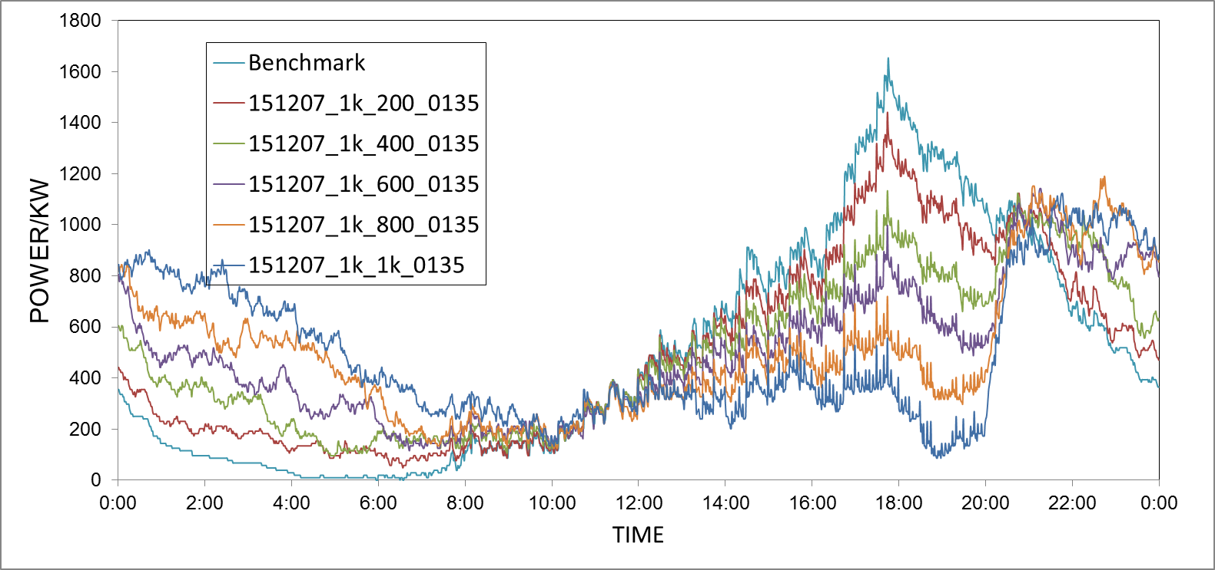

Figure 24: Power consumption after cost optimization with variable number of flexible households

*Cost optimization has influence on robustness of the grid***.** Although only cost is set as an optimization goal in this experiment, we can expect there would still be an influence on the grid’s robustness because the power consumption curves are altered as is shown in Figure 24. By comparing the deviations of different curves in Table 8, we can see the deviations initially drop as the household flexibility increase while grow up after a certain point. This can be understood as: cost optimization makes household to redistribute their power consumption from originally being around 17h00 to being at 20h00 which is the starting of off-peak hours and evenness of such a redistribution which results in the change of the deviations is mainly effected by the household flexible. If the number of households that redistribute their power consumption is comparable with the number of households that do not, the peak at the original peak time would be balanced with the emerging peak, leading to a positive effect on grid robustness. It is also noticeable that the deviations using cost optimization with 400-, 600- and 800- household flexibility are smaller than those using robustness optimization. This reveals that it is incompletely appropriate to evaluate the robustness of grid only with the minimum deviations.

**7 Summary and Outlook**

In the current era of fast development in electrical vehicles application, the simultaneous charging demand of electric vehicles becomes a new challenge for conventional grid to guarantee its stability and capacity.

Therefore, to tackle this raising challenge by using demand response, a model of smart microgrid of EVs is built in this paper. The microgrid model, which represents a certain socially cooperated community with only electric vehicles, collects local power consumption information and determines when each of its member EVs should be charged.

To construct the model, we first simulate the original power consumption of households based on the driving profile of NHTS database. EVs are charged according to the charging plans they receive from the EV agent. Then we optimize the total power consumption of the EV grid with EPOS using robustness and cost as objectives.

Finally, the following key conclusions can be drawn from the experiment.

(1) In smart microgrid, alternative plans with randomness can reach a more stable total electricity consumption and alleviate conventional power grid along the whole day, by shifting non-urgent demand into non-busy hours. And the random charging plans with different charging steps, will have similar improvement on the robustness of the grid.

(2) Increase of the flexible household percentage can improve the robustness of smart microgrid, by near-linearly decreasing the standard deviation of total energy consumption. Therefore, every marginal individual who joins the microgrid, can have a similar contribution to the grid robustness.

(3) When a fixed peak/off-peak price signal is given, the higher the flexible household percentage in smart microgrid, the lower the total energy cost. Therefore, by implementing a smart microgrid, economic benefit can be achieved. However, cost minimization may sacrifice the grid robustness, especially a highly flexible a smartgrid may not alleviate but shift the peak load into the cheap hours.

The result above can be seen highly promising. And the following work are expected in the future.

(1) The Infrastructure deployment in real life

Seeing the advantage of smart microgrid on improving the grid robustness and economic performance, also the advantages of privacy and speed during optimization process, we are looking forward to implementing the model into real community.

(2) Optimization of combined objective in cost and robustness

It is preferred to both consider cost saving and grid robustness in one optimization process, so that the economic and operating benefit of smart microgrid can be simultaneously achieved. This requires a sophisticated and well-designed objective function, which guarantee the optimization can be completed with both feasibility and low-calculating cost.**8 Acknowledgements**

This work has been completed as a course project for *Modelling and Simulating Social Systems with MATLAB* at ETH Zurich. Our team has been supervised by Dr. Evangelos Pournaras and Dr. Lloyd Sanders of the Department of Computational Social Science.

**9 References**

[1] Alt, Lowell (2006), [Energy Utility Rate Setting](http://books.google.com.au/books?id=RW3tycY4TToC). Lulu.com. p. 66. [ISBN](https://en.wikipedia.org/wiki/International_Standard_Book_Number) [1411689593](https://en.wikipedia.org/wiki/Special:BookSources/1411689593). Retrieved 25 June 2013.

[2] Peterson et al.(2010), The economics of using plug-in hybrid electric vehicle battery packs for grid storage, Journal of Power Sources

[3] Landsberg, Dennis R.; Ronald Stewart (1980). [Improving Energy Efficiency in Buildings: A Management Guide](http://books.google.com.au/books?id=M0EnqtFxW3cC). SUNY Press. p. 456. [ISBN](https://en.wikipedia.org/wiki/International_Standard_Book_Number) [1438409990](https://en.wikipedia.org/wiki/Special:BookSources/1438409990).

[4] Jeff Cobb (2015). ["One Million Global Plug-In Sales Milestone Reached"](http://www.hybridcars.com/one-million-global-plug-in-sales-milestone-reached/). HybridCars.com. Retrieved 2015-09-16. U.S. cumulative sales since 2008 totaled 363,265 highway legal plug-in electric passenger cars through August 2015.

[5] Kott, A.; Abdelzaher, T.(2014), Resiliency and Robustness of Complex Systems and Networks. Adapt. Dyn. Resilient Syst. 2014, 67, 67–86.

[6] M. A. López et al. (2011), Optimal Microgrid Operation with Electric Vehicles, 2011 2nd IEEE PES International Conference and Exhibition on Innovative Smart Grid Technologies (ISGT Europe),.

[7] teslamotors.com/models

[8] Residential service rate (2012), Schedule No. 1, EL Paso Electric Company

[9] Pournaras et al. (2014), Decentralized Planning of Energy Demand for the Management of Robustness and Discomfort, IEEE TRANSACTIONS ON INDUSTRIAL INFORMATICS, VOL. 10, NO. 4, NOVEMBER 2014

[10] E. Pournaras, M. Warnier, and F. M. T. Brazier (2010), “Local agent-based self-stabilisation in global resource utilisation,” Int. J. Auton. Comput., vol. 1, no. 4, pp. 350–373, Dec. 2010.

[11] E. Pournaras (2013), “Multi-level reconfigurable self-organization in overlay services,” Ph.D. dissertation, Dept. Multi-actor Syst., Delft Univ. Technol., Delft, The Netherlands, Mar. 2013.

[12] U.S. DoT(2009), National Household Travel Survey, http://nhts.ornl.gov/download.shtml.

[13] U.S. DoT(2009), 2001 National Household Travel Survey: User’s Guide, http:// nhts.ornl.gov/publications.shtml#usersGuide

[14] U.S. DoT(2009), 2001 National Household Travel Survey: Coodbook, http:// nhts.ornl.gov/publications.shtml#coodbook

**10 Appendix**

The list of source codes that can be found on the GitHub repository of our project (“github.com/seoho91/EV_Grid/code)

gen_Matlab_data.m: This script converts the NTHS data from excel format into Matlab’s table format.

FUN_SOCalter.m: This function finds SOC vectors when the original charging and alternative charging plans are applied.

altPlan1test.m: This Sub function finds the SOC when the alternative plan 1 is applied. This plan charges a vehicle fully in one randomly determined charging step.

altPlan2test.m: This Sub function finds the SOC when the alternative plan 2 is applied. This plan charges a vehicle in two charging steps, the first of which starts as soon as the vehicle arrives home; after a pause of random length, the vehicle is charged fully

altPlan3test.m: This Sub function finds the SOC when the alternative plan 3 is applied. This plan charges a vehicle halfway in two randomly determined charging steps.

altPlan4test.m: This Sub function finds the SOC when the alternative plan 4 is applied. This plan charges a vehicle in three discrete steps; the first step starts immediately; breaks among the charging steps are randomly determined.

altPlan5test.m: This Sub function finds the SOC when the alternative plan 5 is applied. This plan charges a vehicle halfway in three randomly determined charging steps.

FUNC_distance.m: This function output distance-t profile for certain household, the inputs include a NTHS table and the Household ID.

FUNC_electricity.m: This function derives electricity consumption from a given SOC.

FUNC_location.m: This function derives location-t profile for a person with a given housed and NTHS table.

FUNC_SOC.m: This function derives state of charge profile in a day from given household ID, given car model and the NTHS table.

FUNC_speed.m: The function gets speed-t profile for a person with a given household ID.

gen_benchmark.m: The script obtains the benchmark total energy consumption, which means all the electric vehicles do not have alternative plans. They charge immediately as soon as they arrive home.

generateSOC.m: This script generates a sample SOC profile for alternative plan testing.

gen_ExpInputData.m: This script generates the experimental input data file and folders for the EPOS optimization engine